 Methods Unit 4 Practice Test

(Calculator Free) Name__________________

Time: 22 minutes Marks: 22

1. [2, 1 marks]

The graph below shows y = loga (x) for x $≤$ 0.

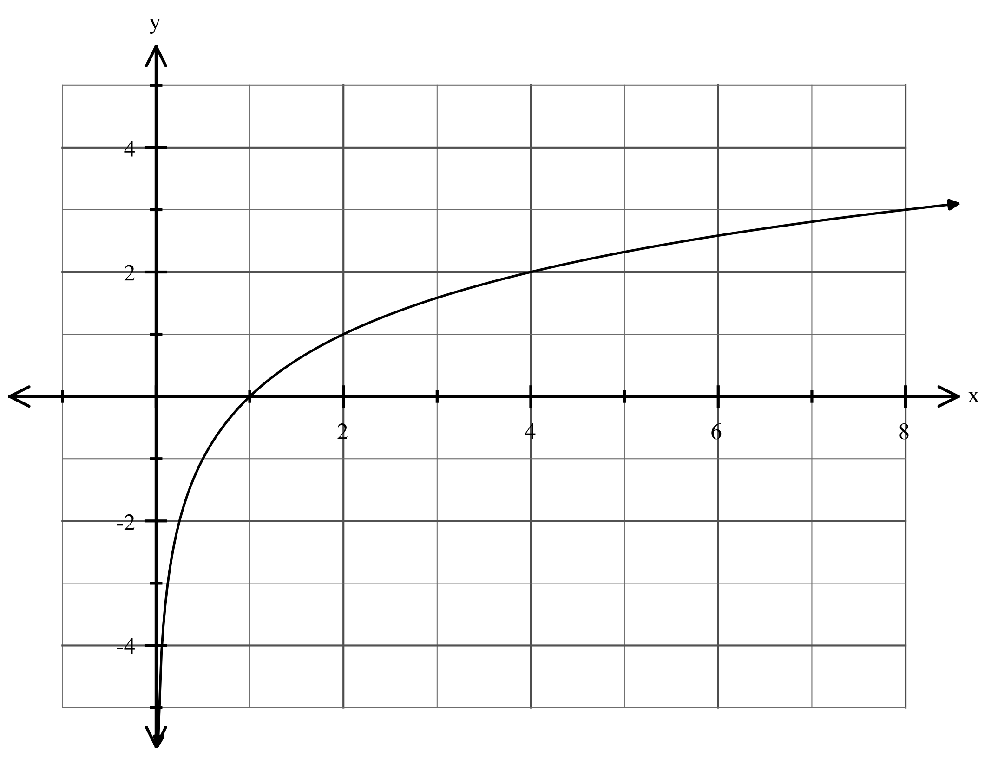

1. Sketch y = loga (x - 1) + 2, clearly indicating any intercepts and/or asymptotes.

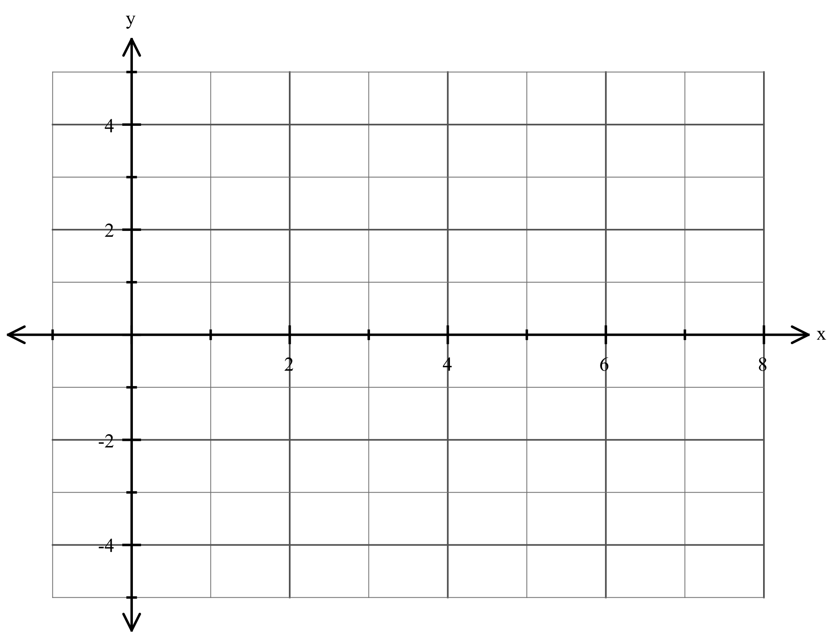

b) Determine a, giving the reasoning behind your answer.

1. [1, 2, 2 marks]

If log 2 = x and log3 = y write in terms of x and y:

a) log 1.5

b) log 72

c) log 1200

3. [2 marks]

Write as a single logarithm:

2log3(x) – ½ log3(y) + 2

1. [4 marks]

An object moves along a straight line such that its displacement, x metres, from the origin at time t seconds, is x = 2t + ln (2t – 1).

Find its velocity and acceleration of the object at t = 1 second.

5. [4 marks]

Show that dx = 0.5 (ln 2 - ln)

6. [1, 3 marks]

Given that y = log3(x + 3),

1. Determine the vertical asymptote.

b) Determine the x- and y-intercepts.



Methods Unit 4 Practice Test

(Calculator Assumed) Name___________________

Time: 43 minutes Marks: 43

7. [2, 4 marks]

The temperature in a freezer once turned on is determined by the function where T = 30 – 15e0.055t, where T is measured in degrees Celsius and t is the time in minutes after the freezer is turned on.

a) By how many degrees (correct to 2 decimal places) does the temperature drop in the first 5 minutes?

b) Demonstrating the use of logarithms, find how long will it will take to reach 00C (correct to the nearest minute).

8. [5 marks]

A continuous random variable X has a p.d.f. such that

f(x) = $\left[\begin{matrix}\frac{3(a+x-0.5x^{2})}{8} & 0≤x≤2 \\ 0 & for all other values of x\end{matrix}\right.$

Determine a.

9. [4 marks]

Find exactly the equation of the tangent to the curve y = ln ($\frac{4}{x+1}$) at the point where x = 1.

10. [3, 3 marks]

a) Find algebraically the intersection of y = $\frac{3}{x}$ and y = 4 – x.

b) By calculus methods, determine exactly the area between these curves.

1. [2, 1, 2 marks]

A continuous random variable X has a pdf such that f(x) = 0.8 – 0.15x defined over interval [1, $a]$

1. Find a.

Determine:

1. P(1.2 $≤$ X $≤$ 2.5)

1. P(X 2 | X 1.5)

12. [2, 2, 2, 2 marks]

Let X be the time (in minutes) it takes for a student to swim 200 metres, where

f(x) = $\left[\begin{matrix}\frac{13-2x}{8} for 2≤x≤3 \\ 0 elsewhere\end{matrix}\right.$

1. Show that this is a probability density function.
2. Determine the mean time.
3. Determine the variance.

1. State the mean time and variance in seconds.

13. [5 marks]

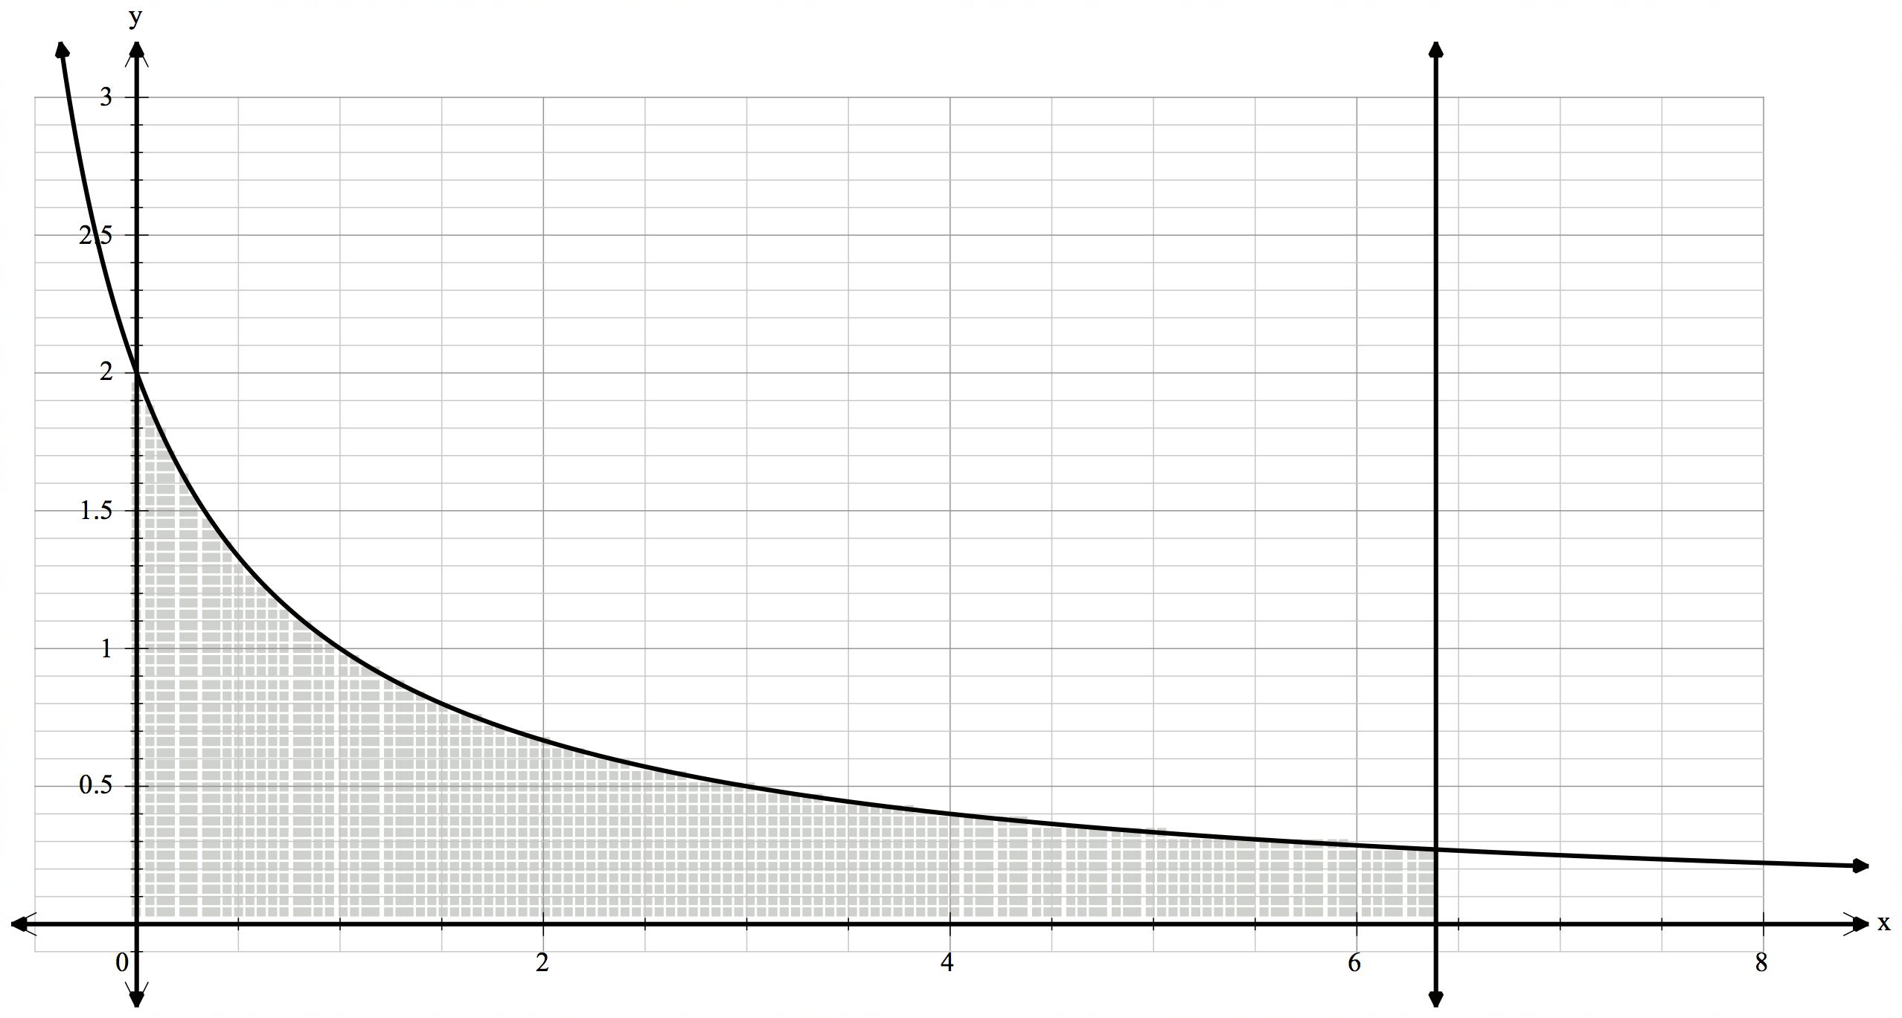

The area between y = $\frac{2}{x+1}$, the x-axis, the y-axis and x = *k* is 4 square units. Determine *k* exactly, showing all reasoning.

14. [4 marks]

If there are x octaves between a note of $f_{1}$ Hertz (Hz) and one of $f_{2}$ Hz then x = $\frac{1}{log2} . log\frac{f_{2}}{f_{1}}$

If there is a frequency range of 3 octaves between $f_{1}$ and $f_{2}$ where $f_{1}$ = 100 Hz, show that $f_{2}$ = 800 Hz.